Database Configuration (DeNA)

* Application-side
  + Vertical splitting
  + Horizontal sharding
  + Read/write splitting
* Infrastructure-side
  + Load-balancing on reader
  + Automatic writer failover

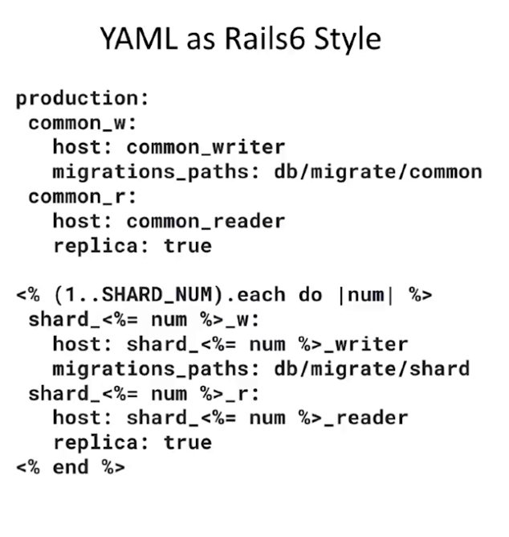

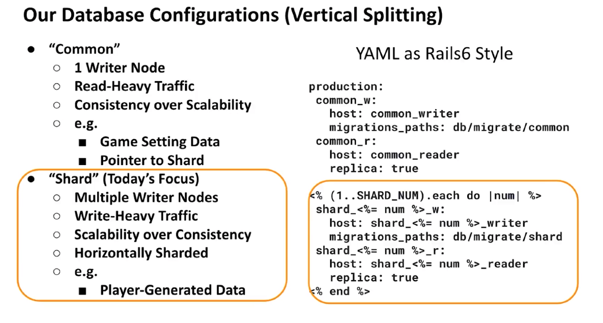

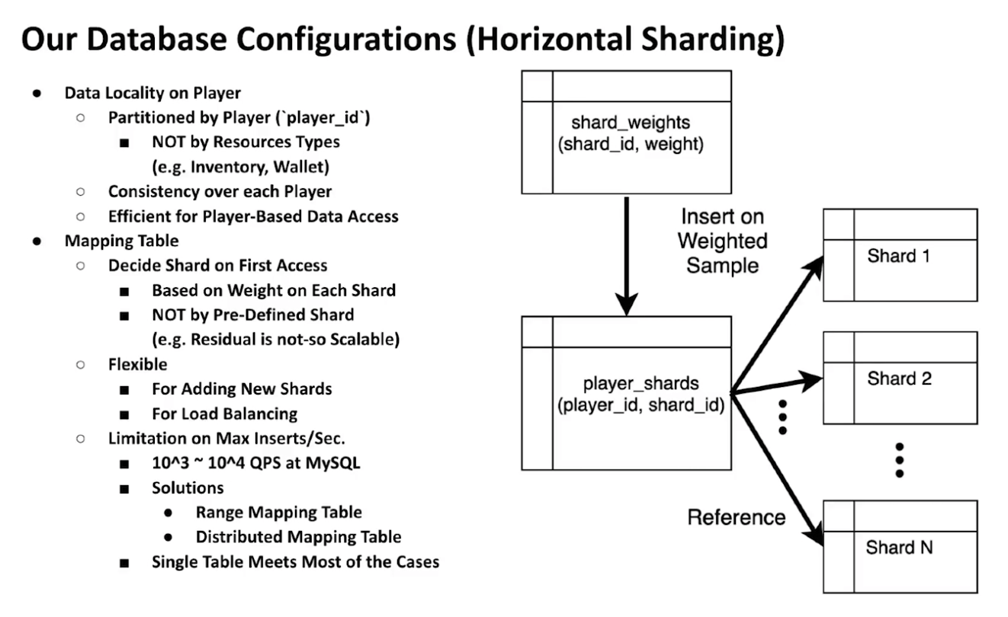

QPS = queries per second

